Exp:7-Determination and plotting of Capacitance of isolated and concentric sphere with different inner and outer radius and dielectric constant of the dielectric mediums.
Aim:
To write program for Capacitance of an isolated sphere and two concentric sphere using SCILAB.

Software required:
•SCILAB version 6.0.1
Theory:
Program:
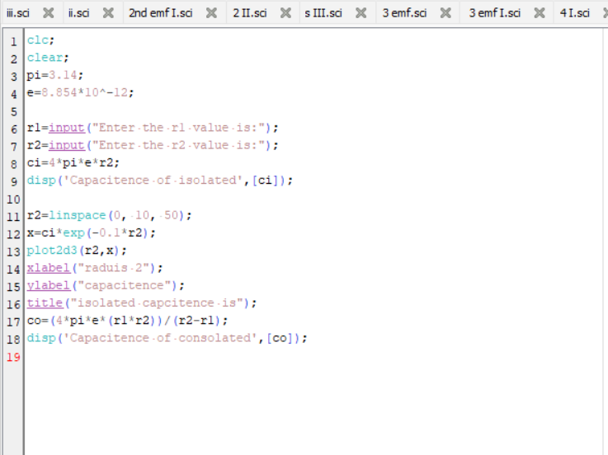
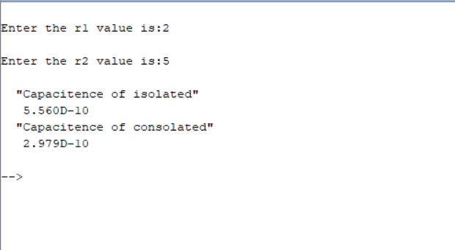
Output:
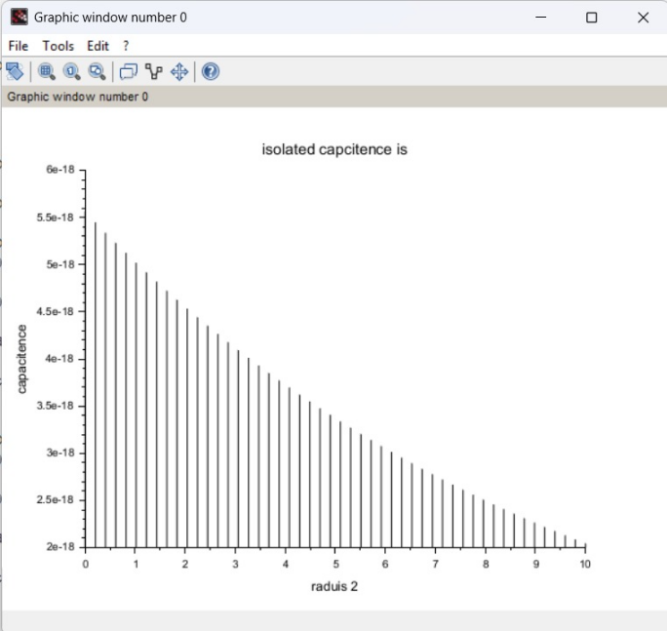
Calculation;
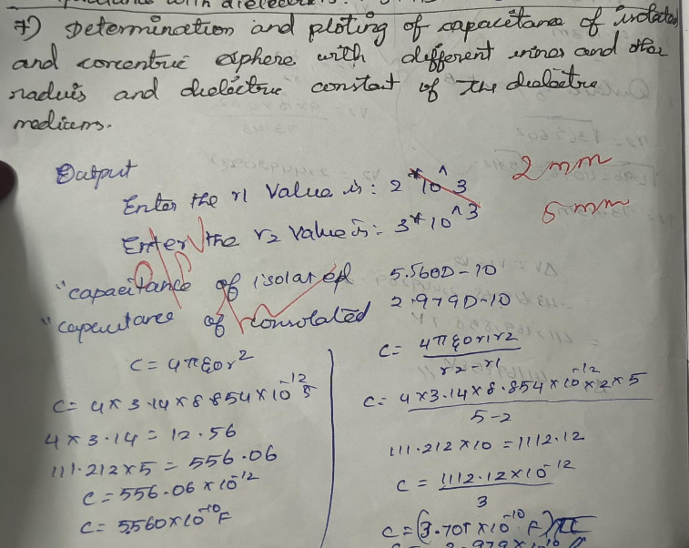

CASE 1:-CONCENTRIC SPHERICAL CAPACITOR WITH DIFFERENT DIELECTRIC MEDIUMS CODE:-
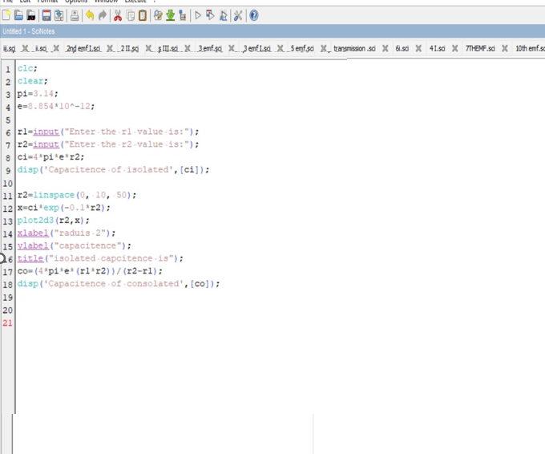
Output:
CASE 2: ISOLATED SPHERE
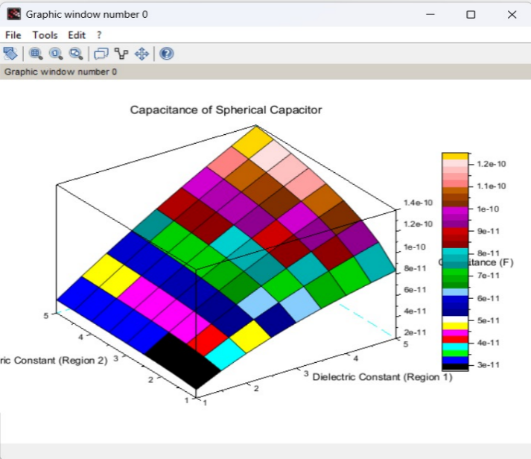
CODE:-
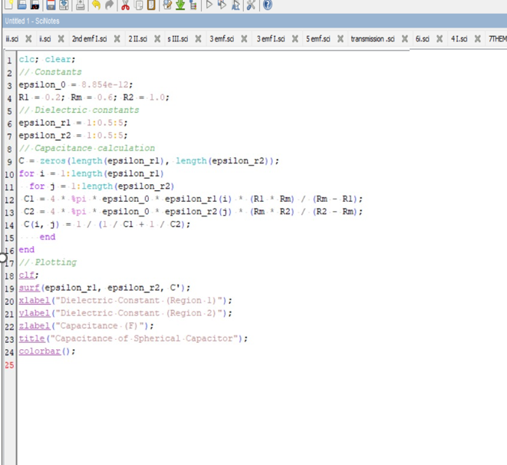
Output:
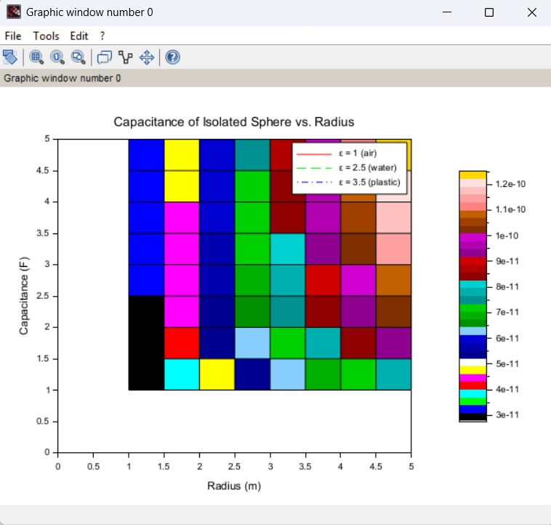

CASE 3: CONCENTRIC SPHERICAL CAPACITOR
CODE:
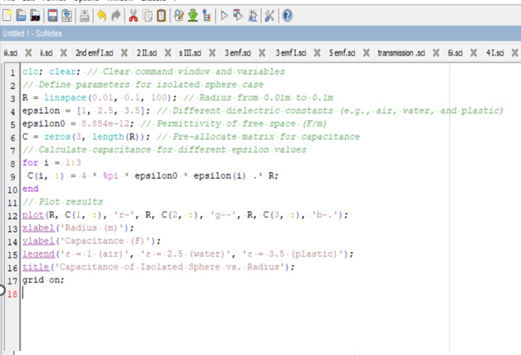
Output:
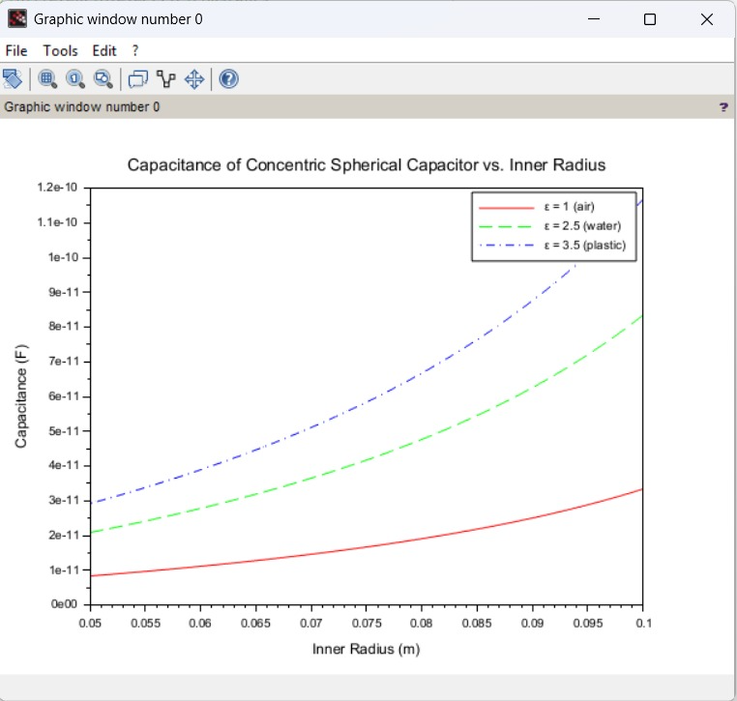

Result :
Thus the program was verified for Capacitance of an isolated sphere and two concentric sphere using SCILAB was successfully.

